**Cpt 22**

**Homework (Simulation)**

1. **Generate random addresses with the following arguments: -s 0 -n 10, -s 1 -n 10, and -s 2 -n 10. Change the policy from FIFO, to LRU, to OPT. Compute whether each access in said address traces are hits or misses.**

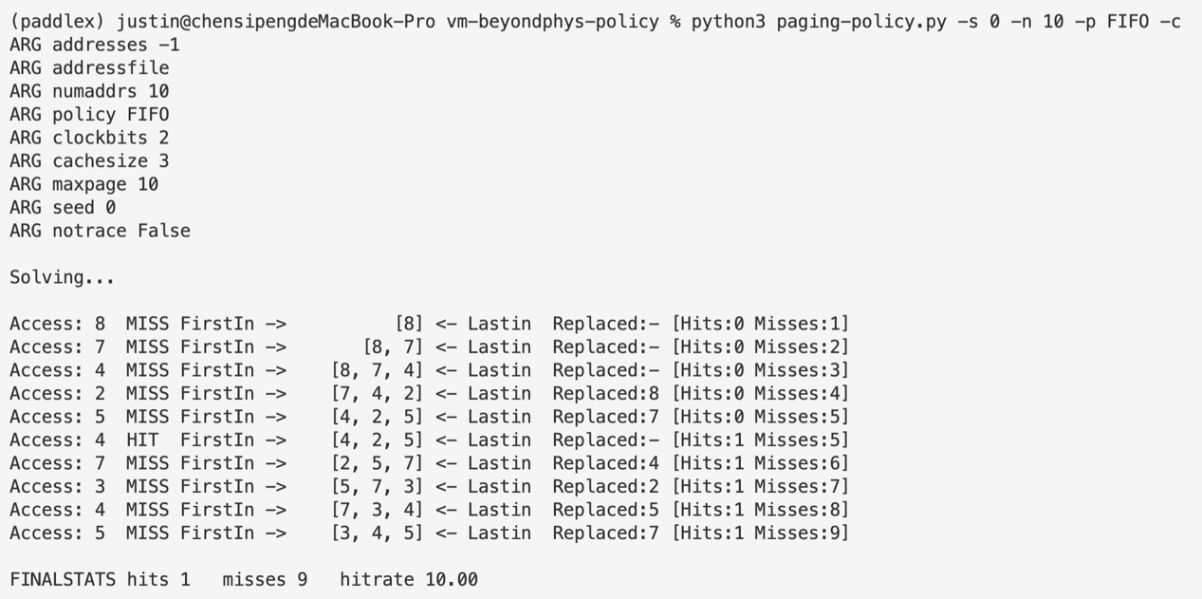

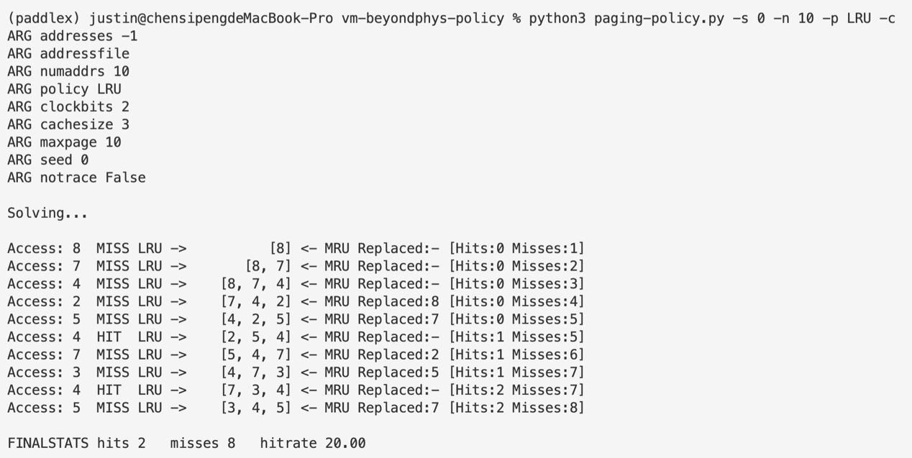

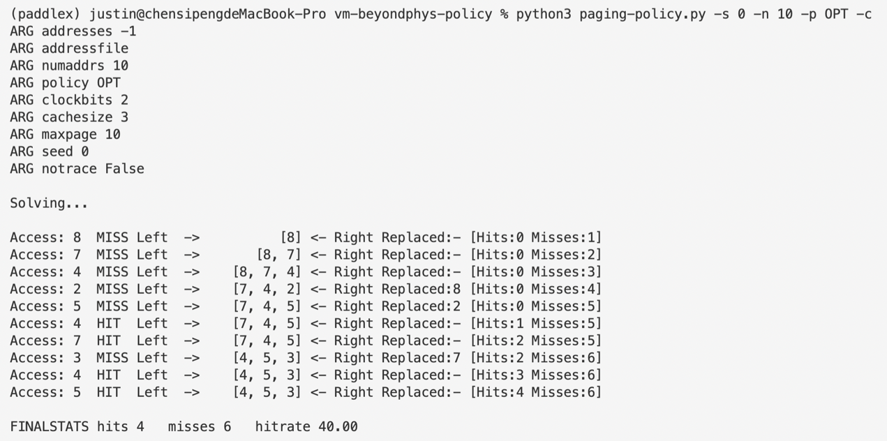

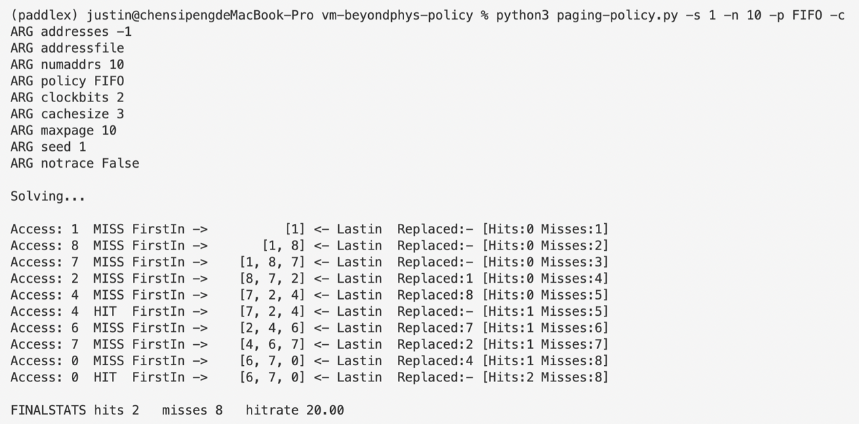

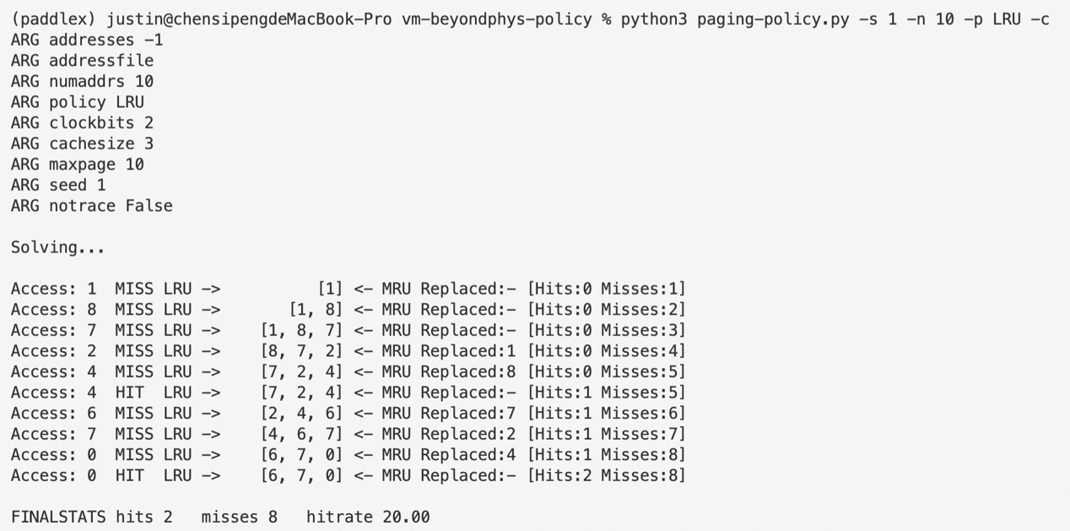

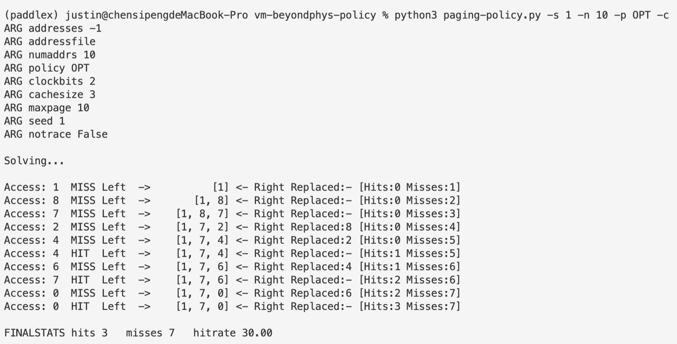

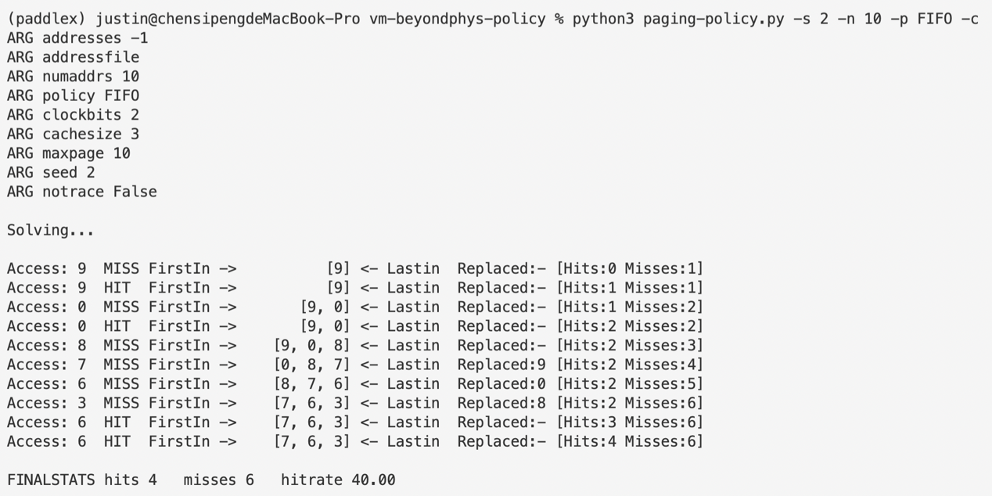

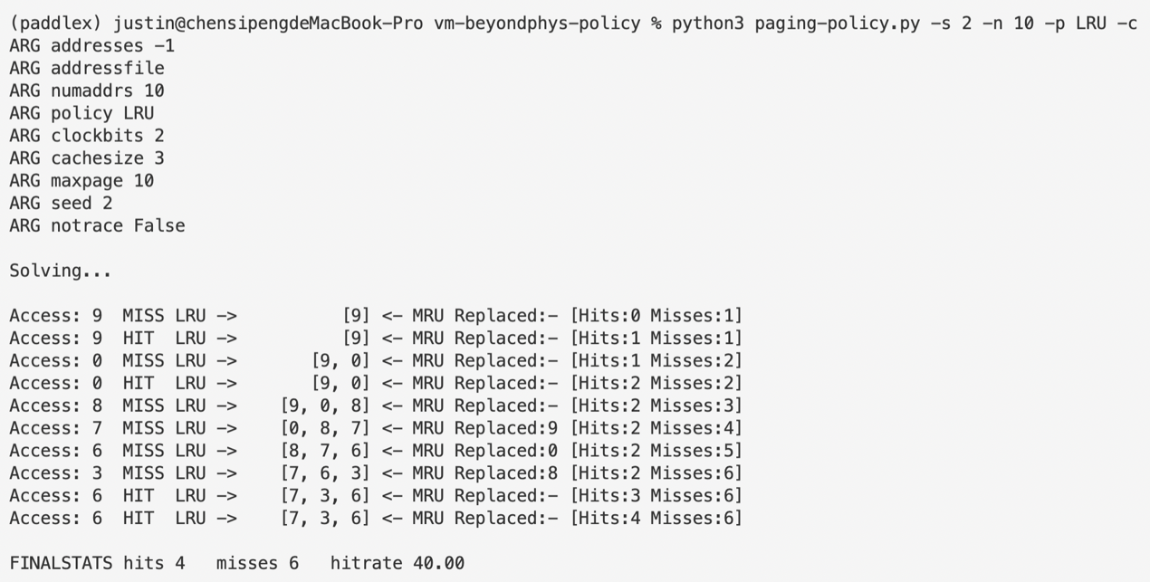

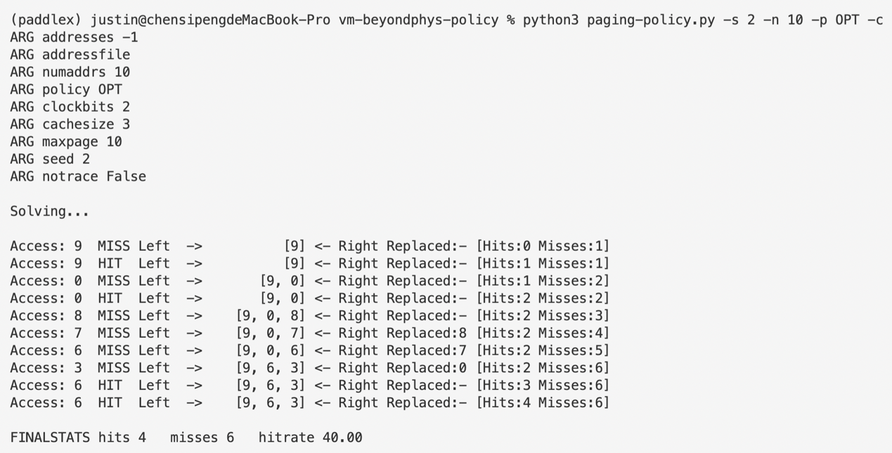

1. **For a cache of size 5, generate worst-case address reference streams for each of the following policies: FIFO, LRU, and MRU (worst-case reference streams cause the most misses possible. For the worst-case reference streams, how much bigger of a cache is needed to improve performance dramatically and approach OPT?**

For FIFO, we simply need to make sure that every time an address is to be accessed, it has just been replaced by some other address, thus making the hit-rate 0. For a size-5 cache, a loop of address accesses 0, 1, 2, 3, 4, 5 will do the job.

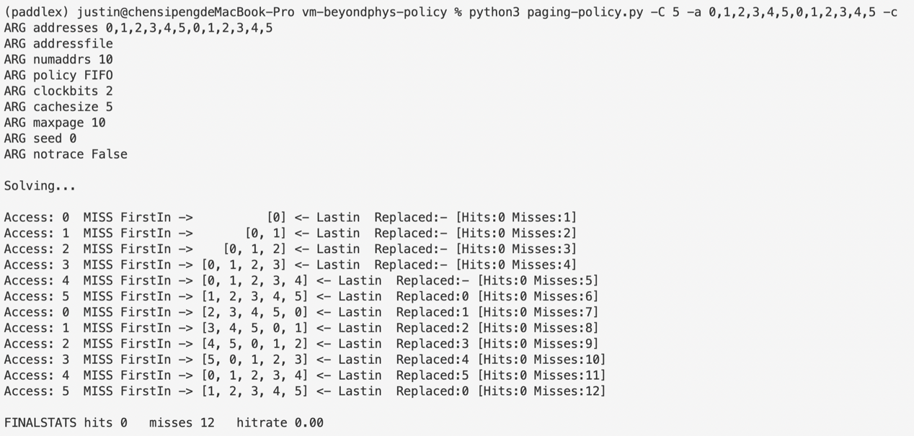

For LRU, the case above will also lead to a hit-rate of 0, as we ensures every address that is currently stored in the cache has only been accessed once since it was stored, so LRU has a same scenario as FIFO.

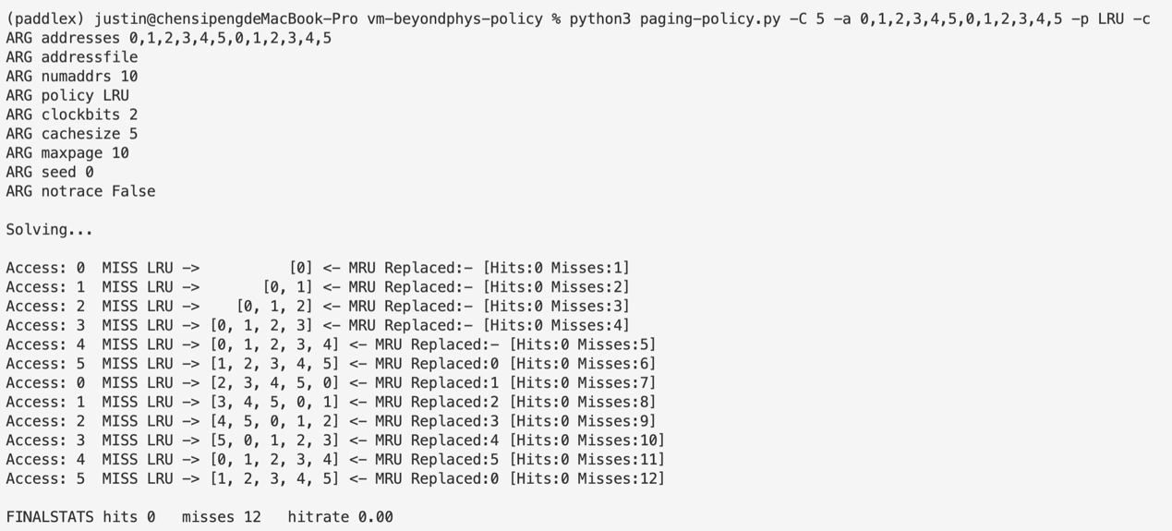

In the two cases above, OPT algorithm has a hit-rate of 41.67.

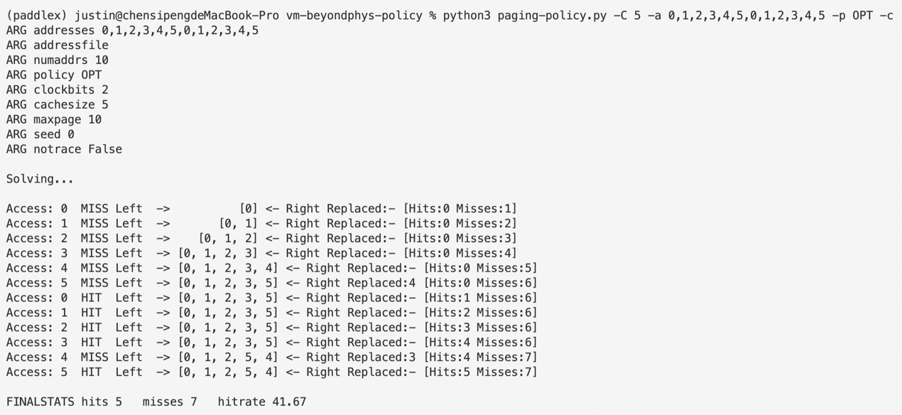

To improve the performance, we will have to increase the cache size by 1, thus making the cache able to hold all addresses from 0 to 5. So apart from the first 6 attempts will be misses, because the cache is empty, attempts later on will all hit, making the hit-rate 50.00, which equals that of OPT.

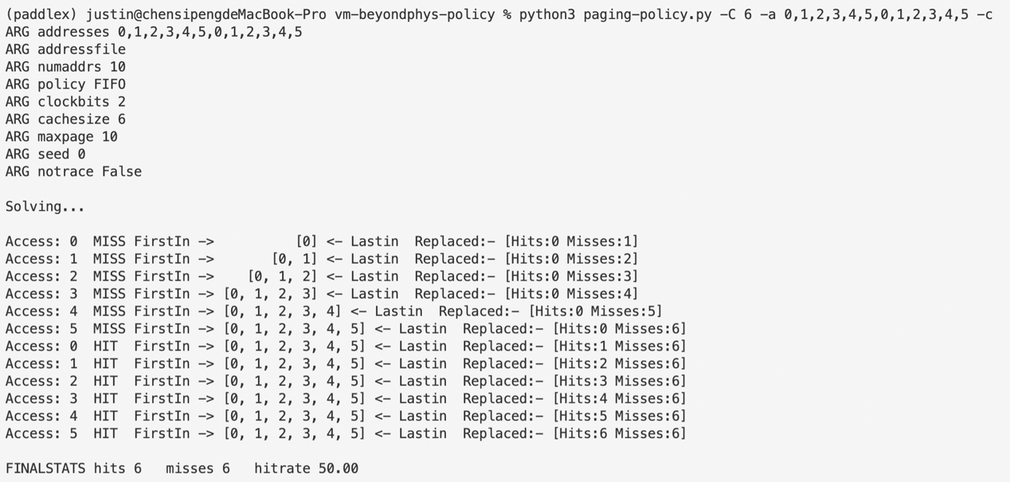

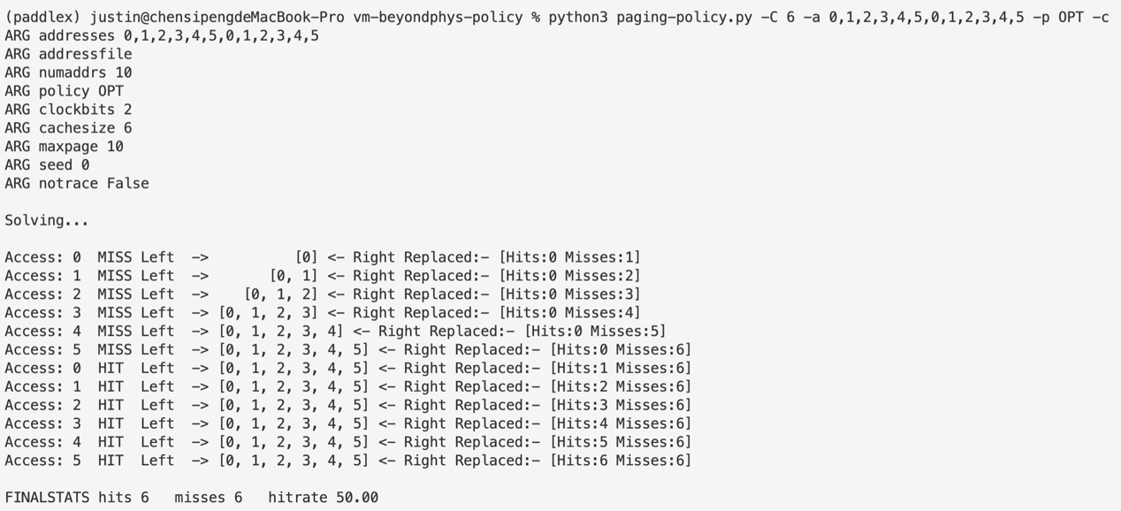

For MRU, since the algorithm will automatically kick out the latest address stored when all addresses stored are equally used, we first cram the cache with addresses 0, 1, 2, 3 and 4, and then access address 4 and 5 alternatively. This can also make hit-rate 0.

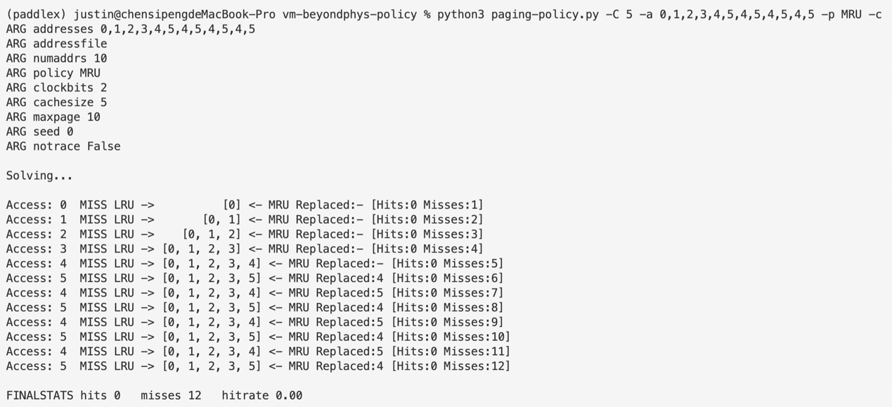

For the case above, OPT has a hit-rate of 50.00.

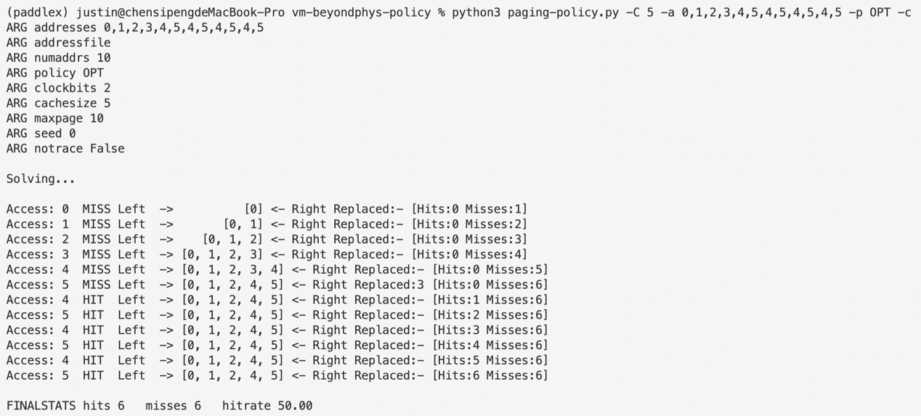

Similar to the approach we used when optimizing FIFO and LRU, in this case we also make cache size 6.

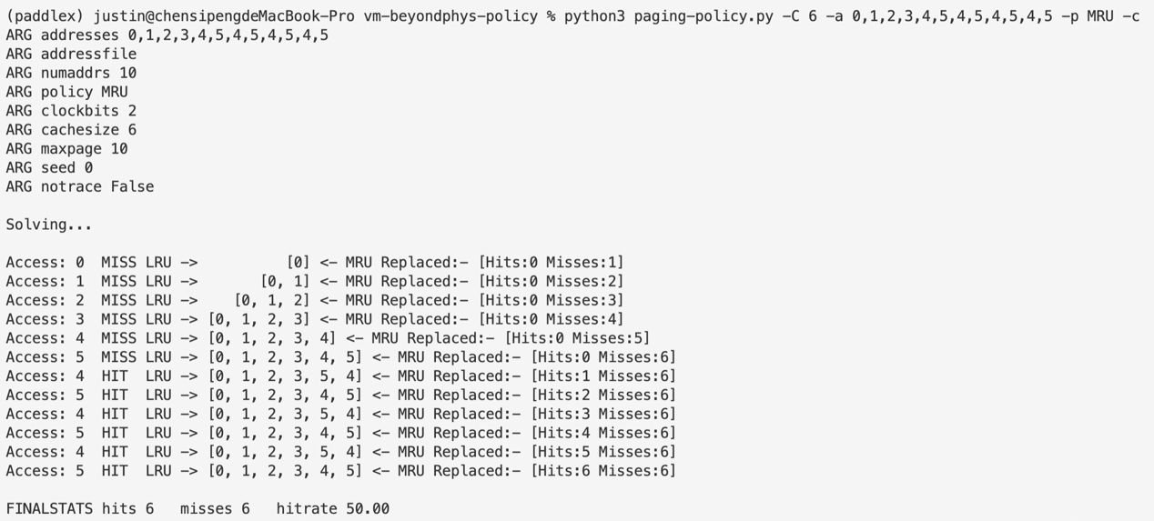

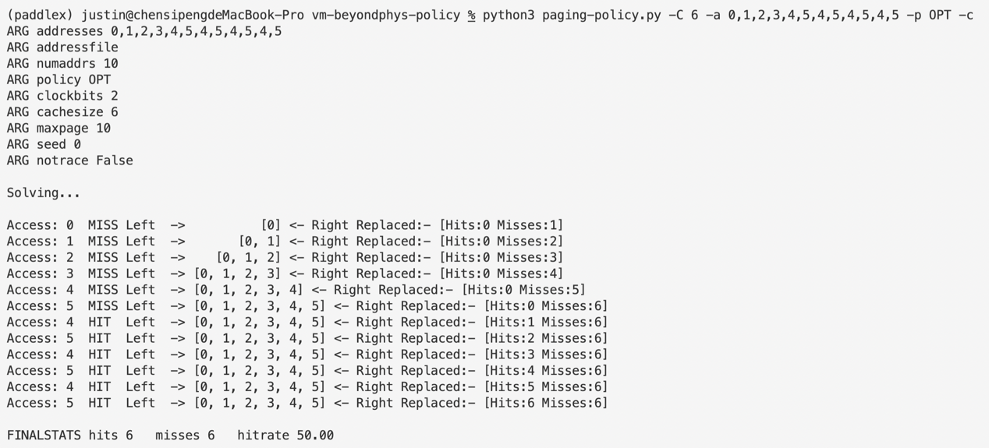

1. **Generate a random trace (use python or perl). How would you expect the different policies to perform on such a trace?**

Generate random traces with the code below (trace-generator.py) …

import **random**

from **optparse** import **OptionParser**

out = []

parser = **OptionParser**()

parser.**add_option**('-n', '--number', default='10', help='number of addresses to generate')

parser.**add_option**('-M', '--max_option', default='10', help='max address generated')

(options, args) = parser.**parse_args**()

num = **int**(options.number)

maximum = **int**(options.max_option)

for i in **range**(0, num):

addr = **random**.randint(0, maximum - 1)

out.**append**(addr)

**print**(f'Generate trace: {out}')

…and the output is shown below.



Compute with paging-policy.py.

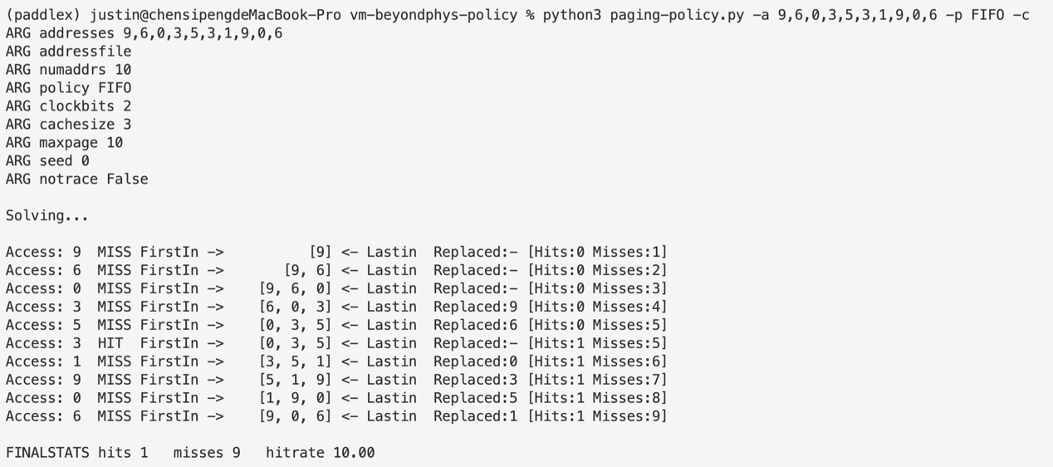

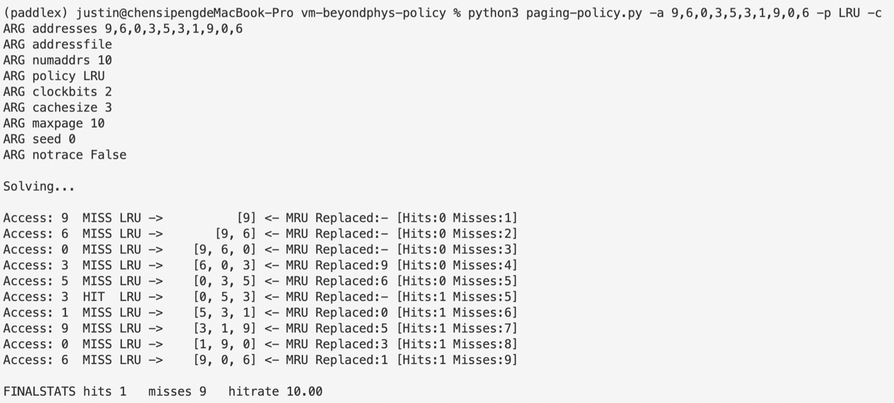

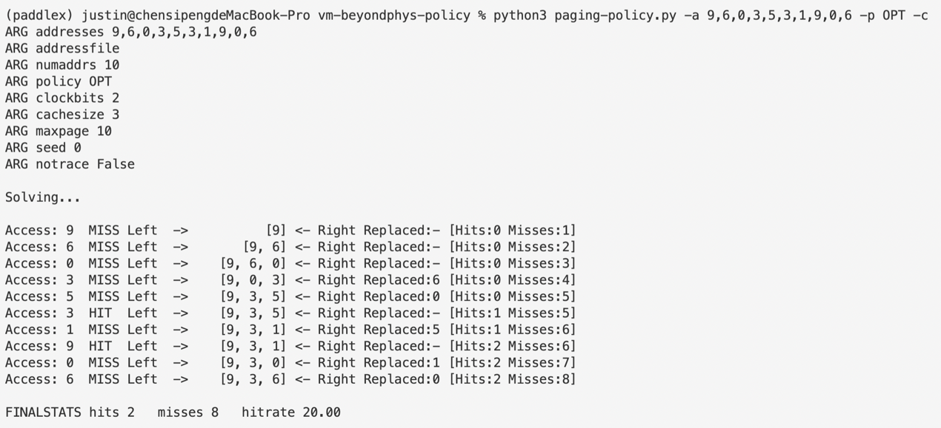

We can see that the hit-rate of OPT is, as we would expect, slightly higher than that of FIFO and LRU.

1. **Now generate a trace with some locality. How can you generate such a trace? How does LRU perform on it? How much better than RAND is LRU? How does CLOCK do? How about CLOCK with different numbers of clock bits?**

Locality can be easily achieved by adding a threshold every time we roll a random address to access. By default, we set the threshold 0.8 and roll a ticket to decide whether we should choose an address within the first one third of the whole address space, if the ticket is larger than 0.8, or, if smaller, the latter two thirds.

import **random**

from **optparse** import **OptionParser**

out = []

parser = **OptionParser**()

parser.**add_option**('-n', '--number', default='10', help='number of addresses to generate')

parser.**add_option**('-M', '--max_option', default='10', help='max address generated')

parser.**add_option**('-t', '--threshold', default='0.8', help='threshold for locality')

(options, args) = parser.**parse_args**()

num = **int**(options.number)

maximum = **int**(options.max_option)

focus = **int**(maximum / 3)

threshold = **float**(options.threshold)

for i in **range**(0, num):

key = **random**.random()

**print**(key)

if key >= threshold:

addr = **random**.randint(focus, maximum - 1)

else:

addr = **random**.randint(0, focus - 1)

out.**append**(addr)

**print**(f'Generate trace: {out}')

Run the modified generator and get the following output:

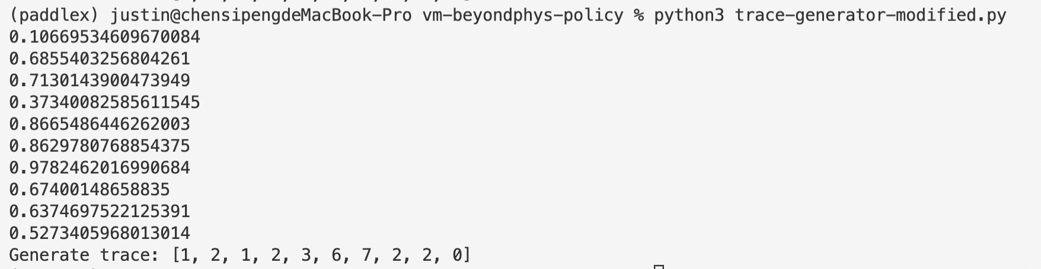

Now test the generated trace with paging-policy.py:

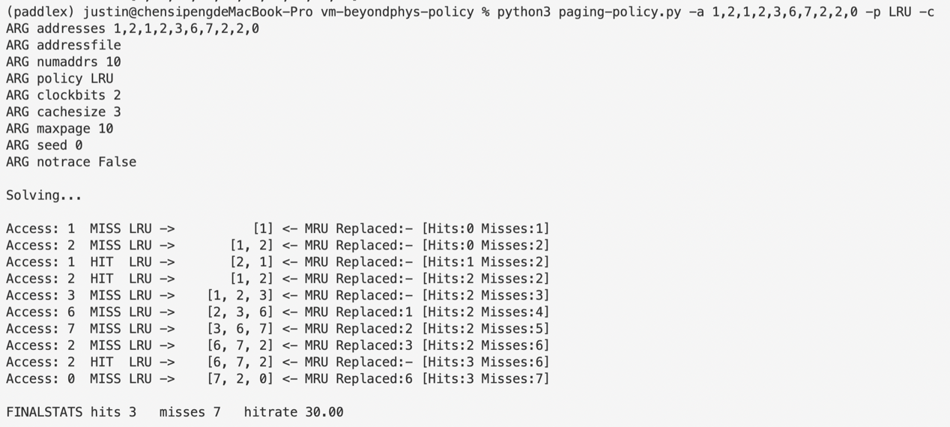

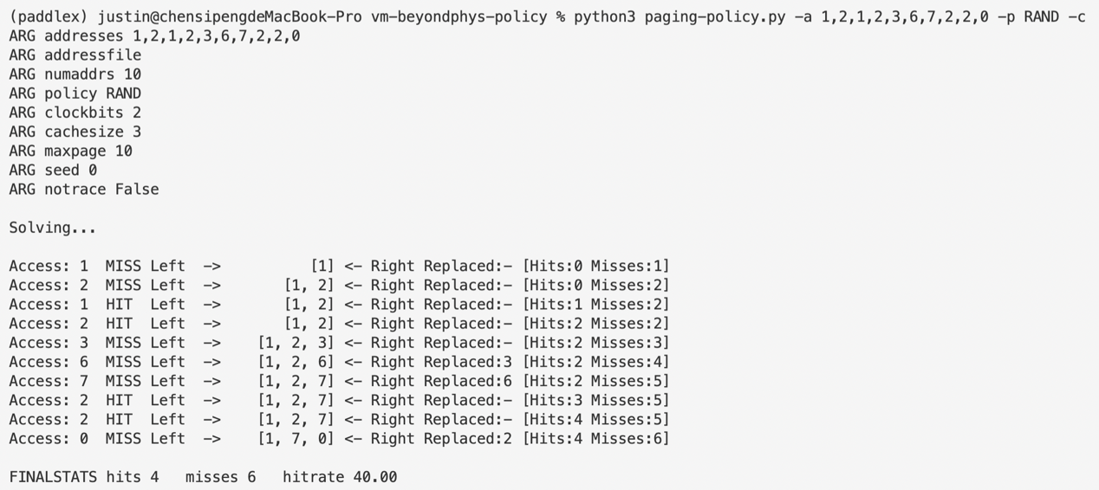

We can see that the hit-rate of RAND is 10 percent higher than that of LRU.

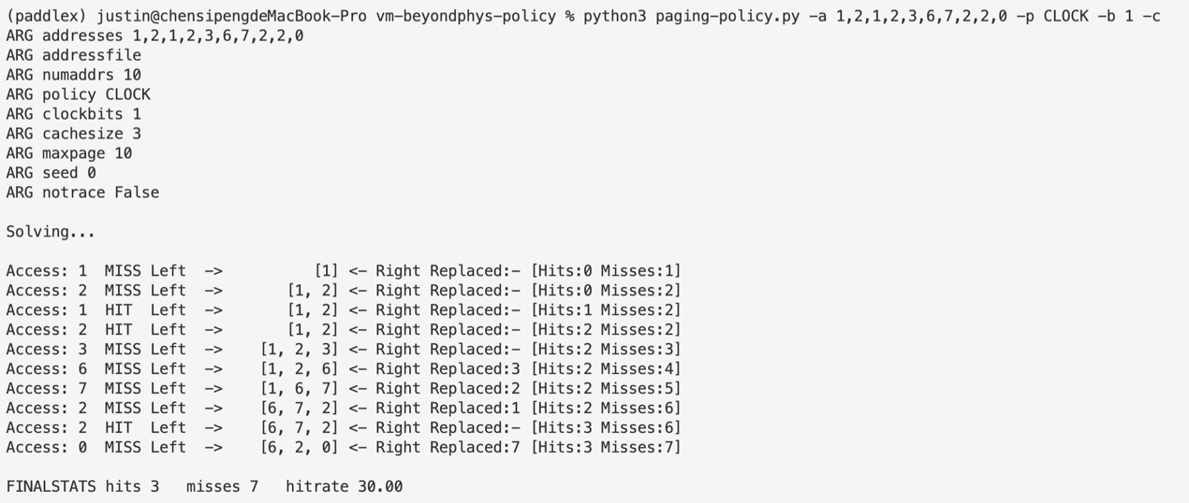

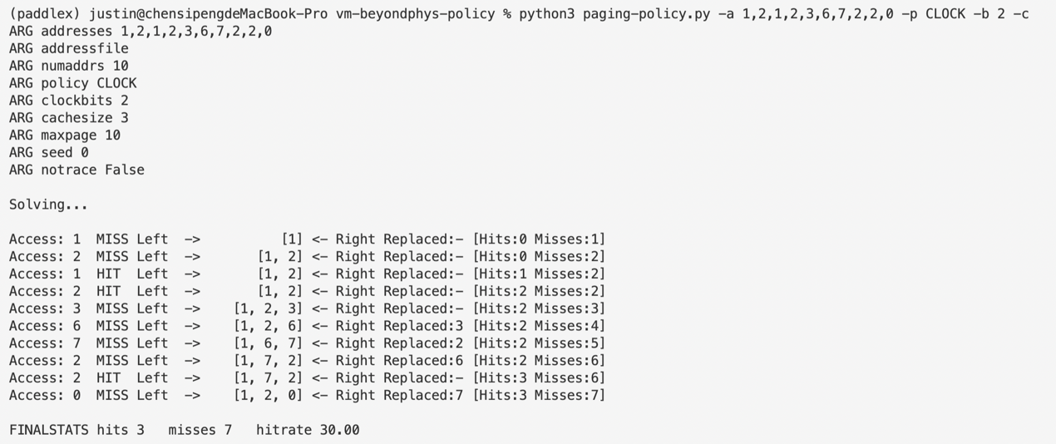

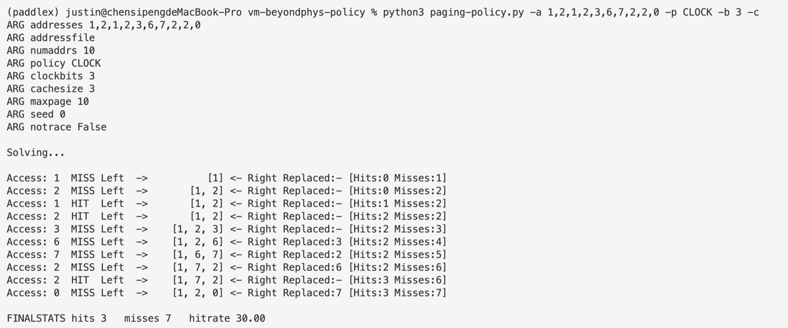

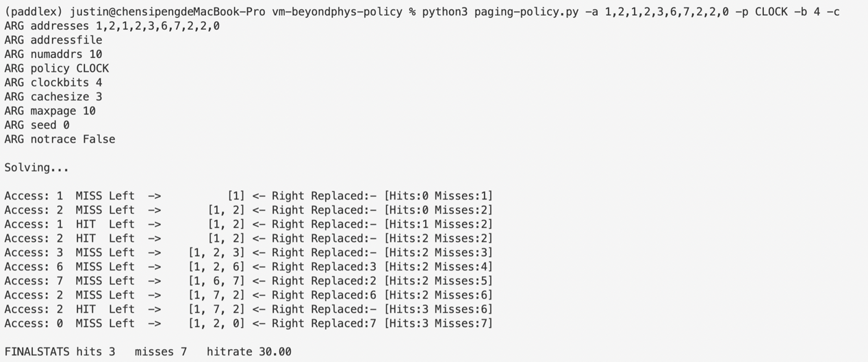

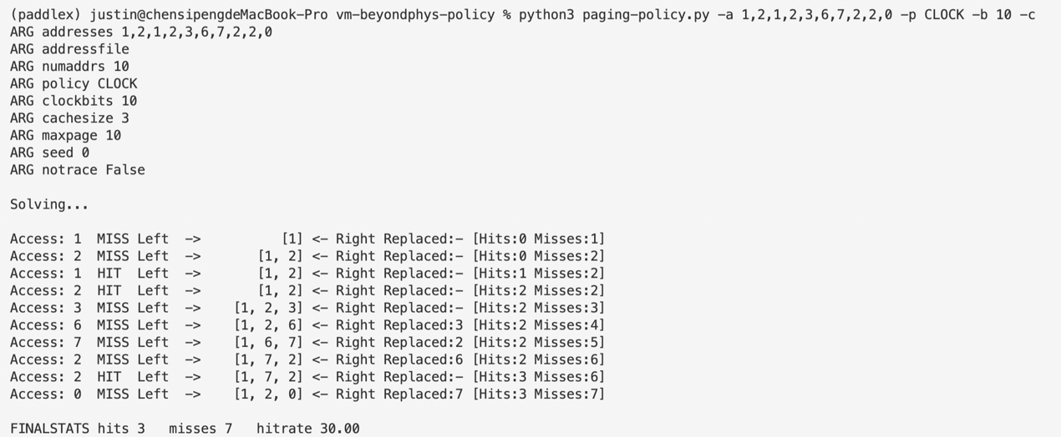

Trials above shows that in this case, hit-rate for CLOCK remains unchanged as we alter the value of clockbits. CLOCK will always have a hit-rate of 30, which equals that of LRU.

1. **Use a program like valgrind to instrument a real application and generate a virtual page reference stream. For example, running valgrind --tool=lackey --trace-mem=yes ls will output a nearly-complete reference trace of every instruction and data reference made by the program ls. To make this useful for the simulator above, you’ll have to first transform each virtual memory reference into a virtual page-number reference (done by masking off the offset and shifting the resulting bits downward). How big of a cache is needed for your application trace in order to satisfy a large fraction of requests? Plot a graph of its working set as the size of the cache increases.**

Run the command above and interrupt it immediately with ^c and store the output in a text file valgrind.txt. Transform the virtual memory into vpn with code below:

filename = 'valgrind.txt'

file = **open**(filename, 'r')

addrfilename = 'addrfile.txt'

file_addr = **open**(addrfilename, 'w')

for line in file.**readlines**():

if (not line.**startswith**('=')):

vm = line.**split**(' ')[-1]

vm = vm.**split**(',')[0]

vpn = ((**int**('0x' + vm, 16)) & 0xfffff000) >> 12

file_addr.**write**(**str**(vpn) + '\n')

where “&0xfffff000” calculates the highest 5 digits of the virtual address, and then cut out the latter 3 digits by shifting it right. The results are stored in file addrfile.txt. Now, run paging-policy.py with commands below:

python3 paging-policy.py -f addrfile.txt -p FIFO -C 1 -c



python3 paging-policy.py -f addrfile.txt -p FIFO -C 2 -c



python3 paging-policy.py -f addrfile.txt -p FIFO -C 3 -c



python3 paging-policy.py -f addrfile.txt -p FIFO -C 4 -c



python3 paging-policy.py -f addrfile.txt -p FIFO -C 5 -c



python3 paging-policy.py -f addrfile.txt -p LRU -C 1 -c



python3 paging-policy.py -f addrfile.txt -p LRU -C 2 -c



python3 paging-policy.py -f addrfile.txt -p LRU -C 3 -c



python3 paging-policy.py -f addrfile.txt -p LRU -C 4 -c



python3 paging-policy.py -f addrfile.txt -p LRU -C 5 -c



python3 paging-policy.py -f addrfile.txt -p OPT -C 1 -c



python3 paging-policy.py -f addrfile.txt -p OPT -C 2 -c



python3 paging-policy.py -f addrfile.txt -p OPT -C 3 -c



python3 paging-policy.py -f addrfile.txt -p OPT -C 4 -c



python3 paging-policy.py -f addrfile.txt -p OPT -C 5 -c



Now plot the result with matplotlib using the outputs above:

